

|  |
| --- |
| School of Computing  Faculty of Engineering AND PHYSICAL SCIENCES |

A Comparative Study of Serverless Architectures

Fernando Jesús Rodriguez Lopez

Submitted in accordance with the requirements for the degree of  
Advanced Computer Science (Cloud Computing) MSc Science)

**2023/2024**

The candidate confirms that the following have been submitted*:*

*<As an example>*

|  |  |  |
| --- | --- | --- |
| **Items** | **Format** | **Recipient(s) and Date** |
| *Deliverables 1, 2, 3* | *Report* | *SSO (xx/xx/xx)* |
| *Participant consent forms* | *Signed forms in envelop* | *SSO (xx/xx/xx)* |
| *Deliverable 4* | *Software codes or URL* | *Supervisor, assessor (xx/xx/xx)* |
| *Deliverable 5* | *User manuals* | *Client, supervisor (xx/xx/xx)* |

Type of Project: empirical investigation

The candidate confirms that the work submitted is their own and the appropriate credit has been given where reference has been made to the work of others.

I understand that failure to attribute material obtained from another source may be considered plagiarism.

(Signature of student)

© <Year of Submission> The University of Leeds and <full name of candidate>

# Summary

*This investigation intends to explore the landscape of serverless computing, identifying the primary challenges and motivations behind the adoption and enhancement of Function-as-a-service (FaaS) platforms. Elaborating a comparative analysis of leading serverless architectures, including Knative and Azure Functions. The project seeks to evaluate performance and scalability. By developing a suite of benchmarks tailored to assess these platforms, this study intends to offer insights into their comparative advantages, limitations, and suitability for real-world application scenarios.*

***<Reminder about basic requirements of layout and format:***

***The report must be in typescript, sequentially page numbered, on A4, single or double-sided, with 1in margins. Point size 11 and one-and-a-half line spacing should be used.***

***Page Numbering: The pages preceding the body of the text, i.e. from "Summary" to "Contents" inclusive, should be sequentially numbered in Roman numerals. All the remaining pages should be numbered in a single sequence of Arabic numerals.***

***Length: The main body of a 60 credit project report must be no longer than 60 pages (i.e. excluding appendices and references). The limit for 40-credit projects is 50 pages.>***

# Acknowledgements

*<This page should contain any acknowledgements to those who have assisted with your work. Where you have worked as part of a team, you should, where appropriate, reference to any contribution made by others to the project.*

*Note that it is not acceptable to solicit assistance on ‘proof reading’ which is defined as “the systematic checking and identification of errors in spelling, punctuation, grammar and sentence construction, formatting and layout in the text”; see* [*http://www.leeds.ac.uk/qat/documents/policy/Proof-reading-policy.pdf*](http://www.leeds.ac.uk/qat/documents/policy/Proof-reading-policy.pdf)*. >*

# Table of Contents

Summary iii

Acknowledgements iv

Table of Contents v

Chapter 1 Level 1 Heading with ‘heading 1’ Style Applied by Pressing Ctrl Shift 1 1

1.1 Level 2 Heading with ‘heading 2’ Style Applied by Pressing Ctrl Shift 2 **Error! Bookmark not defined.**

1.1.1 Level 3 Heading with ‘heading 3’ Style Applied by Pressing Ctrl Shift 3 **Error! Bookmark not defined.**

1.1.1.1 Level 4 Heading with ‘heading 4’ Style Applied by Pressing Ctrl Shift 4 **Error! Bookmark not defined.**

Chapter 2 Tables and Figures 3

2.1 Tables using the ‘table caption’ and ‘table description’ Styles 41

2.2 Figures using the ‘figure caption’ and ‘figure description’ Styles 41

List of References 42

Appendix A External Materials 43

A.1 Level 2 Heading with ‘heading 2’ Style Applied by Pressing Ctrl Shift 2 43

A.1.1 Level 3 Heading with ‘heading 3’ Style Applied by Pressing Ctrl Shift 3 43

A.1.1.1 Level 4 Heading with ‘heading 4’ Style Applied by Pressing Ctrl Shift 4 43

Appendix B Ethical Issues Addressed 44

B.1 Level 2 Heading 44

# Chapter 1 Introduction

Serverless computing has emerged as a transformative paradigm in cloud computing, allowing developers to build and deploy applications without the need to manage the underlying infrastructure. Function-as-a-Service (Faas) platforms have gained increasing adoption due to their potential for cost efficiency, scalability, and simplification of deployment processes, becoming easy and fast to perform. As organisations seek to optimise their technology resources and reduce operational complexities, the move towards serverless architectures has accelerated. However, the serverless computing landscape is not without its challenges, such as performance inconsistencies, cold start latency issues, and limitations in managing the application state.

The landscape of serverless computing currently has a variety of solutions, including cloud-native proprietary solutions and open-source platforms. Platforms like Knative and Azure functions highlight the diversity of available options. Knative, as an open-source project, offers a desirable option for developers and enterprises looking to leverage cloud technologies without being locked into proprietary ecosystems. This open-source nature fosters a collaborative community and allows for greater flexibility and customisation to meet specific needs. Azure functions offer managed serverless environments with deep integrations into the Azure cloud ecosystem; this platform provides ease of use and seamless integration with other cloud services, but it could also present challenges related to vendor lock-in and limited customisation.

Understanding the distinct advantages and constraints of these platforms—both open-source and proprietary—is crucial for developers and enterprises aiming to effectively implement serverless technologies in real-world applications. This project aims to address this need by conducting a detailed analysis of these architectures, utilizing a comprehensive set of benchmarks to assess performance and scalability under diverse conditions. The emphasis on open-source solutions, such as Knative, Apache OpenWhisk, and Kubeless, reflects a growing interest in flexible, community-driven, cost-effective alternatives within the cloud computing landscape.

## Project Aim

This investigation aims to explore the landscape of serverless computing, identifying the primary challenges and motivations behind the adoption and enhancement of Function-as-a-service (FaaS) platforms. Elaborating a comparative analysis of leading serverless architectures, including Knative and Azure Functions. The project seeks to evaluate performance and scalability. By developing a suite of benchmarks tailored to assess these platforms, this study intends to offer insights into their comparative advantages, limitations, and suitability for real-world application scenarios.

## Objectives

* Develop a set of benchmarks aimed at evaluating and testing the performance (in terms of effectiveness and efficiency) and scalability aspects of serverless platforms under  varied conditions and for real-world application scenarios
* Understand and compare serverless computing architectures by exploring the core challenges and motivations driving the adoption of Function-as-a-Service (FaaS) platforms in different scenarios.
* Analyze and contrast the performance and scalability of the serverless architectures under different conditions, collecting data to establish a baseline for comparison.
* Understand and interpret the collected data to identify patterns and anomalies that reveal the comparative advantages, limitations, and operational behavior of the serverless platforms under different scenarios.
* Formulate strategic recommendations based on the interpreted results that guide stakeholders in selecting a serverless architectures for optimal performance in real-world scenarios, and ensuring the replicability of the experiments by making all benchmarks, tools, and collected data publicly available through documentation, supporting open science principles and enabling further research and validation by the community.

## Deliverables

* A project report presenting the research findings, including the literature review, platform analysis, comparative analysis, and evaluations.
* A collection of benchmarks developed for this project, including software artifacts created, scripts, and documentation on how to use them, the scenarios they cover, and guidelines for interpreting the results.
* A dataset generated by the collected data result of the execution of benchmarks developed for this research made them available for further research and analysis.

# Chapter 2 Background and Literature Review

This chapter will focus on a review of the literature on serverless computing, detailing both proprietary and open-source platforms. It will examine the architectural principles, performance challenges, and existing benchmarking solutions relevant to Function-as-a-Service (Faas) platforms. Additionally, the chapter will justify the need to develop new benchmarks tailored to specific research objectives.

## Background

## The Serverless Computing Landscape

This model abstracts the complexity of managing infrastructure, allowing developers to deploy code without provisioning or managing servers; this not only simplifies the development process but also enables enterprises to avoid maintaining a dedicated server provisioning and management team. The fundamental premise of serverless computing is to let developers focus on the implementation of business logic, with the cloud provider handling the operational aspects such as scaling, patching and infrastructure management. This abstraction is made possible by leveraging Function-as-a-Service (FaaS) platforms, which execute individual functions in response to events.

The serverless model is built upon several key principles and concepts:

* + - 1. **Event-Driven Architecture**

Serverless computing operates on an event-driven architecture where functions are triggered by events such as HTTP requests, database changes, or message queues. This architecture enables applications to be highly responsive and scalable, as functions are only executed in response to events, ensuring efficient resource utilisation.

1. **Microservices**

Serverless applications are often composed of fine-grained microservices, each performing a specific task. This modularity facilitates easier updates, testing, and scaling of individual components. The microservices architecture aligns well with serverless computing, promoting a decoupled and resilient system design .

1. **Scalability**

One of the core benefits of serverless computing is automatic scalability. Cloud providers dynamically allocate resources to handle incoming requests, scaling up during peak times and scaling down during low-traffic periods. This elasticity is crucial for handling unpredictable workloads without manual intervention.

1. **Cost Efficiency**

Serverless platforms follow a pay-as-you-go pricing model, where users are billed based on the number of executions and the duration of each execution. This model can lead to significant cost savings, especially for applications with variable or unpredictable traffic patterns. Users do not need to pay for idle resources, a major advantage over traditional infrastructure.

1. **Cold Start Latency**

Despite its benefits, serverless computing faces challenges like cold start latency. When a function is invoked after being idle, the cloud provider must allocate resources and initialise the function's runtime environment. This initialisation delay can impact the performance of latency-sensitive applications.

1. **Statelessness**

Serverless functions are inherently stateless, meaning they do not retain any state between executions. While this simplifies scaling and resource management, it also requires developers to use external storage solutions for state persistence, which can add complexity to application design.

1. **Security and Compliance**

Serverless platforms introduce new security considerations. The ephemeral nature of serverless functions and the shared responsibility model require robust security practices to ensure applications' confidentiality, integrity, and availability. Compliance with regulatory requirements must also be addressed, especially when handling sensitive data.

* 1. **Serverless Architectures**
     1. **Proprietary Solutions**

Proprietary serverless solutions offer managed environments that deeply integrate with their respective cloud ecosystems. These platforms are user-friendly and well-documented but may lead to vendor lock-in and limited customization.

* Azure Functions: Azure Functions integrate deeply with the Azure ecosystem, offering extensive features for building and deploying serverless applications. However, its reliance on Azure-specific services can limit flexibility for multi-cloud strategies
* AWS Lambda: AWS Lambda, one of the first major FaaS offerings, supports multiple programming languages and triggers. Its scalability and reliability are well-documented, but it similarly risks vendor lock-in within the AWS ecosystem (
  + 1. **Open-Source Solutions**

Open-source serverless platforms offer greater flexibility and avoid vendor lock-in. They can be deployed on various environments, promoting a truly cloud-native approach.

* Knative: Developed by Google, Knative is a Kubernetes-based platform that runs serverless workloads on any cloud or on-premises environment. It fosters collaboration and flexibility (Baldini et al., 2017; Roberts, 2016).
* Apache OpenWhisk: This platform supports multiple languages and can be deployed on-premises or in the cloud, offering extensive customization options (Spillner, 2017; van Eyk et al., 2017).
* Kubeless: As a Kubernetes-native serverless framework, Kubeless allows functions to be deployed as native Kubernetes resources, leveraging the extensive Kubernetes ecosystem (Jonas et al., 2019; Baldini et al., 2017).
  1. **Benchmarking in Serverless Computing**

Benchmarking is crucial for evaluating the performance and scalability of serverless platforms. It involves running standardized tests to measure metrics such as CPU usage, memory consumption, and API response times. Benchmarks help identify strengths and weaknesses, providing valuable insights for optimizing serverless applications.

* + 1. **Existing Benchmarking Solutions**

Several benchmarking suites assess serverless platforms, offering a range of metrics and scenarios for comprehensive evaluation.

* **ServerlessBench**: This suite offers flexible benchmarks tailored for serverless computing, supporting multiple languages and platforms, including both open-source and commercial solutions (Villamizar et al., 2015; Baldini et al., 2017).
* **SeBS** (Serverless Benchmark Suite): SeBS focuses on FaaS platforms, providing benchmarks for various workloads, including computational tasks and data processing (Adzic & Chatley, 2017; Jonas et al., 2019).
* **FaaSdom**: This suite evaluates serverless environments, focusing on scalability, cold start latency, and resource utilization (Spillner, 2017; Wang et al., 2018).
* **BBServerless**: Designed for bursty traffic scenarios, BBServerless uses representative applications to test platform performance under sudden traffic spikes, identifying potential bottlenecks (Roberts, 2016; Brennan & Kolyshkin, 2018).
  1. **Challenges and Limitations of Existing Benchmarks**

While existing benchmarks provide valuable insights, they also have limitations. Many focus on specific metrics like latency or throughput, potentially overlooking other important factors such as state management efficiency and real-world workload performance. Additionally, most benchmarks use synthetic workloads that may not accurately reflect the complexities of real-world applications.

Limitations:

* **Synthetic Workloads:** Many benchmarks use synthetic workloads that do not accurately reflect the complexities of real-world applications. This can lead to performance metrics that are not fully representative of actual operational conditions (van Eyk et al., 2017; Jonas et al., 2019).
* **Focus on Specific Metrics:** Existing benchmarks often focus on a narrow set of performance metrics such as latency or throughput. This narrow focus can overlook other critical aspects like state management efficiency, resource utilization, and operational costs (Baldini et al., 2017; Spillner, 2017).
* **Cold Start Latency:** Cold start latency is a well-known challenge in serverless computing, yet it is often not adequately addressed in existing benchmarks. Understanding the frequency and impact of cold starts is crucial for performance-sensitive applications (Wang et al., 2018; Jonas et al., 2019).
* **State Management:** Serverless functions are stateless by design, but many real-world applications require state persistence. Existing benchmarks do not always account for the complexities and performance impacts of integrating external state management solutions (Adzic & Chatley, 2017; Baldini et al., 2017).
* **Scalability Testing:** While some benchmarks test for scalability, they may not simulate the highly variable and unpredictable traffic patterns that characterize many modern applications. This can result in scalability metrics that are not fully indicative of real-world performance (Villamizar et al., 2015; Jonas et al., 2019).
* **Security and Compliance Considerations:** Security and compliance are critical in serverless environments, especially when handling sensitive data. Existing benchmarks often do not evaluate how well serverless platforms meet these requirements under different operational conditions (Brennan & Kolyshkin, 2018; van Eyk et al., 2017).
* **Vendor-Specific Features:** Proprietary benchmarks may include optimizations that take advantage of vendor-specific features, making it difficult to generalize findings across different platforms. This can lead to biased results that do not accurately represent the capabilities of the platform under standard conditions (Wang et al., 2018; Jonas et al., 2019).
  1. **Justifying New Benchmarks**

Given these limitations, there is a clear need for developing new benchmarks as part of this project to address specific research objectives and fill existing gaps in the literature. The creation of new benchmarks will:

* Reflect Real-World Applications: By using actual application scenarios and workloads, new benchmarks will offer more relevant insights into platform performance under practical conditions, providing a more accurate representation of how these platforms perform in real-world scenarios.
* Explore Emerging Platforms: As new serverless platforms and features are continuously developed, new benchmarks will ensure the inclusion of the latest technologies, keeping the evaluation current and relevant.
* Address Specific Research Gaps: By focusing on overlooked factors such as cold start mitigation strategies and state management efficiency, new benchmarks will comprehensively evaluate platform capabilities, addressing areas that existing benchmarks may miss.
* Enhance Comparability: Custom benchmarks will enable direct comparison between specific platforms under controlled and consistent conditions, aiding in informed decision-making and providing clear, actionable insights for developers and enterprises.

## Literature Review

This section reviews previous research related to serverless computing and FaaS technologies, highlighting foundational concepts, advancements, and challenges.

Serverless computing, also known as FaaS, allows developers to execute functions without managing the underlying infrastructure. This paradigm shift was pioneered by Amazon with AWS Lambda and followed by other cloud providers such as Google Cloud Functions and Microsoft Azure Functions [1]. The key benefit of FaaS is the ability to scale functions automatically based on demand, which reduces costs and improves resource utilization.

From a business perspective, Google offers the "Cloud Healthcare API," a serverless solution designed to share data in the HL7.FHIR format. This API enables seamless integration with various systems and leverages Google's infrastructure for efficient, web-native scaling. Users can activate the API and submit requests without needing to set up initial capacity. The Cloud Healthcare API supports various data standards, including HL7v2, FHIR, and DICOM, ensuring interoperability across different healthcare systems. It also provides robust security and compliance features, being a covered service under the Google Cloud HIPAA Business Associate Agreement (BAA), which means it can handle electronically protected health information[4]. The Cloud Healthcare API bridges the gap between traditional healthcare systems and modern cloud-based applications by supporting industry-standard data formats and protocols. It integrates seamlessly with other Google Cloud services like Cloud Dataflow for streaming data processing, BigQuery for scalable analytics, and Cloud Machine Learning Engine for advanced machine learning applications. This solution facilitates the ingestion, storage, and analysis of healthcare data, offering a scalable and compliant solution for healthcare data management using Function-as-a-Service (FaaS) technologies [4][5].

Several open-source frameworks have been developed to avoid vendor lock-in and provide more flexible deployment options. Palade, Kazmi, and Clarke (2019) evaluated four open-source serverless frameworks—Kubeless, Apache OpenWhisk, OpenFaaS, and Knative—on their performance in an edge computing environment. Their study highlighted the potential of these frameworks to improve Quality of Service (QoS) by leveraging local computational capabilities [3].

Knative is an open-source platform designed to simplify the deployment and management of serverless workloads on Kubernetes. Developed by Google in collaboration with other industry leaders, Knative extends Kubernetes by providing higher-level abstractions for building, deploying, and managing serverless applications, thereby addressing the complexities associated with Kubernetes (Palade, Kazmi, & Clarke, 2019)[3].

Knative offers robust scaling capabilities and flexibility, making it suitable for complex serverless applications that require extensive event handling and integration. Despite its slightly higher response times under load, Knative’s modularity and Kubernetes integration make it a strong contender for organisations adopting serverless computing (Palade et al., 2019)[3].

As Palade, Kazmi, and Clarke (2019) reported in their investigation "An Evaluation of Open Source Serverless Computing Frameworks Support at the Edge," Knative demonstrated robust performance in an edge computing environment, with competitive throughput and success rates compared to other frameworks like Kubeless and OpenFaaS. However, it exhibited higher response times under increased load. Despite these latency issues, Knative's integration with Kubernetes, advanced auto-scaling capabilities, and modularity make it a strong candidate for complex serverless applications. Its ability to efficiently handle event-driven architectures and seamlessly scale resources underscores its potential, though initial setup complexity remains a challenge.[3]

The efficiency of resource utilisation in serverless computing is another critical aspect. The study "Optimized Resource Usage with Hybrid Auto-scaling System for Knative Serverless Edge Computing" by Kritikos and Skrzypek (2023) discusses a hybrid auto-scaling system that optimizes resource usage by combining horizontal and vertical scaling strategies. They found that this system adjusts the number of instances and their resource allocation dynamically based on real-time demand, significantly enhancing the performance and cost-efficiency of Knative in edge computing environments [6]. This hybrid approach ensures that resources are allocated efficiently, reducing wastage and improving the overall performance of the serverless applications.

The integration of FaaS with IoT devices allows for scalable and efficient data processing. Research byJonas et al. (2019) explores the challenges and opportunities in using serverless computing for IoT, highlighting the benefits of reduced operational overhead and improved resource utilization. This study provides a foundation for developing IoT applications that leverage the flexibility and scalability of serverless architectures. They found that the serverless model was particularly effective in handling the bursty nature of IoT data, providing on-demand scalability without the need for pre-provisioned infrastructure [7].

## Methods and Techniques

This section discusses the general methods and techniques used in research to evaluate and solve problems in various domains, including mathematical modelling, simulation, and direct experiments. Each technique offers unique strengths and is suited to different types of research questions and scenarios.

**Mathematical Modelling**

Mathematical modelling involves creating abstract representations of real-world systems using mathematical language and concepts. These models can describe relationships between variables, predict outcomes, and provide insights into complex systems.

Definition and Purpose:

* Mathematical modelling is the process of translating real-world problems into mathematical expressions. It aims to understand, explain, and predict the behaviour of systems through equations, functions, and algorithms.
* Models can be deterministic, where outcomes are precisely determined through known relationships, or stochastic, where randomness and probabilities are incorporated.

Applications:

* Mathematical models are widely used in fields such as physics, engineering, economics, biology, and environmental science.
* For example, in epidemiology, models can predict the spread of diseases, and in finance, they can forecast market trends.

Strengths and Limitations:

* Strengths: Mathematical models can provide deep insights, allow scenario testing, and help optimise systems.
* Limitations: They require accurate data and assumptions, and their complexity can make them difficult to solve or interpret. Model simplifications overlook important nuances of real-world systems.

Simulation

Simulation involves creating a virtual model of a system and experimenting with it to observe behaviours and outcomes under various conditions. It allows researchers to test scenarios without the risks and costs associated with real-world experiments.

Definition and Purpose:

* Simulation is the imitation of the operation of a real-world process or system over time. It involves using models to conduct experiments and analyse the potential behaviours and performance of the system.
* The primary purpose is to gain insights into system behaviour, evaluate the impact of different variables, and support decision-making processes.

Applications:

* Simulations are extensively used in aerospace, automotive, healthcare, military, and manufacturing.
* For instance, flight simulators are used for pilot training, and healthcare simulations can improve surgical procedures and patient care practices.

Strengths and Limitations:

* Strengths: Simulations can model complex and dynamic systems, allow for risk-free experimentation, and are cost-effective compared to real-world trials.
* Limitations: They may not capture all real-world complexities and require accurate data and assumptions to be effective. The quality of the simulation model directly impacts the reliability of the results.

Direct Experiments

Direct experiments involve conducting tests or trials in controlled or natural settings to observe and measure phenomena. This empirical approach is fundamental to the scientific method.

Definition and Purpose:

* Direct experiments are systematic procedures carried out under controlled conditions to test hypotheses, validate theories, or determine the effects of variables.
* The main goal is to obtain empirical data that can confirm or refute theoretical predictions and contribute to scientific knowledge.

Applications:

* Direct experiments are used across all scientific disciplines, including chemistry, biology, physics, psychology, and social sciences.
* For example, clinical trials test the efficacy of new drugs, and psychological experiments study human behaviour under various stimuli.

Strengths and Limitations:

* Strengths: Direct experiments provide reliable and reproducible data, offer insights into causal relationships, and validate theoretical models.
* Limitations: They can be resource-intensive, time-consuming, and sometimes ethically or practically challenging. Environmental factors and experimental design can also introduce biases or errors.

**Technology Stack**

For this project, the following technology stack is used to conduct the experiments:

* Knative and Azure Functions: These are the primary FaaS platforms being evaluated.
* Virtual Machine in Azure: This VM hosts a Kubernetes cluster with Minikube, which deploys Knative.
* Python 3.9: The programming language used for the experimental functions to simulate real-world scenarios.
* Azure Cloud Services: Including an Azure Storage Bucket and an Azure-managed PostgreSQL database for data storage and management.

These tools and platforms are selected to provide a comprehensive evaluation of serverless computing solutions, ensuring the experiments reflect real-world conditions.

Kubernetes Overview:

Kubernetes, also known as K8s, is an open-source system designed for automating the deployment, scaling, and management of containerised applications. It groups containers that make up an application into logical units for easy management and discovery. Kubernetes builds upon 15 years of experience running production workloads at Google, combined with best-of-breed ideas and practices from the community (Kubernetes, 2024).

Kubernetes is designed to scale without increasing the operations team size, leveraging the same principles that allow Google to run billions of containers a week. Its flexibility ensures consistent and easy delivery of applications, regardless of complexity, from local testing to running a global enterprise. Kubernetes’ open-source nature allows it to be used on-premises, in hybrid environments, or in public clouds, providing the freedom to move workloads as needed.

Kubernetes supports horizontal scaling, which involves deploying more Pods in response to increased load. This can be done via commands, a UI, or automatically based on CPU usage. The Horizontal PodAutoscaler automatically updates a workload resource, such as a Deployment or Stateful Set, to match demand. It adjusts the number of Pods based on metrics like CPU and memory utilisation, providing an efficient way to handle varying workloads (Kubernetes, 2024).

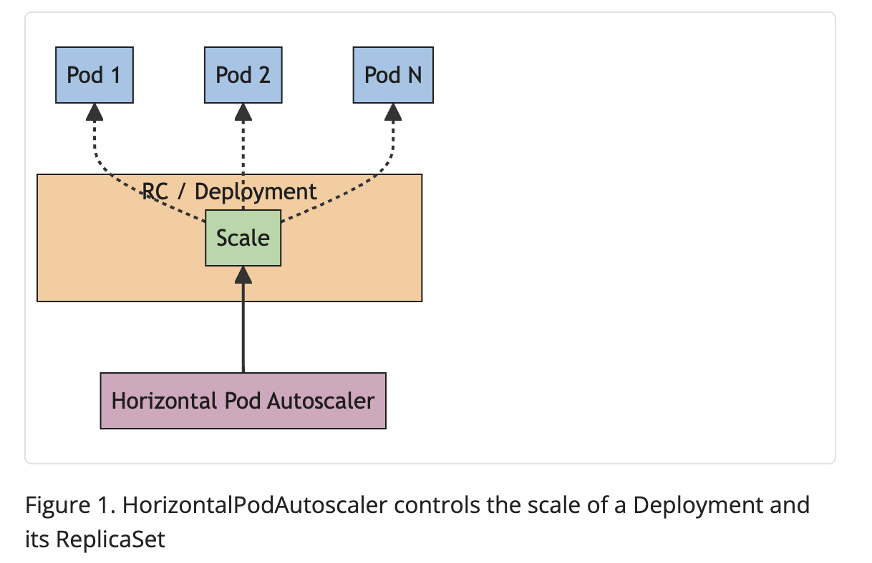

#TODO

**Knative.**

**……**

**Azure Functions**

**…..**

**FHIR**

**…**

**HAPI FHIR**

**…**

**BLOB STORAGE**

**…..**

**DATABASE**

**…**

**APPLICATIONS**

**…**

## Choice of Methods

This section describes the chosen methods, tools, and techniques for the project, providing justifications for their selection.

**Chosen Method: Direct Experiments**

Justification:

Direct experiments have been chosen as the primary method for this project based on the following considerations:

* Empirical Investigation: Direct experiments provide empirical data that accurately reflects the platforms' performance and scalability in real-world scenarios.
* Relevance: Experiments allow for the evaluation of key metrics such as execution time, response time, and resource utilisation, which are critical for assessing the effectiveness of serverless platforms.
* Control: Conducting experiments in a controlled environment ensures consistency and comparability across different platforms.

**Methodology: Empirical Investigation**

Study Design:

* Objective: Evaluate FaaS platforms (Knative, Azure Functions).
* Approach: Use standardised benchmarks in a controlled testing environment.

Experimental Design:

* Performance: Evaluate execution times, response times, and resource utilisation.
* Scalability: Assess each platform's ability to handle varying loads and auto-scale.

Data Collection:

* Metrics: Execution time, response time, CPU/memory usage, network I/O.
* Tools: Prometheus for monitoring, Grafana for visualisation, and custom scripts for data gathering.

Data Analysis:

* Techniques: Statistical analysis (means, standard deviations) and comparative analysis.
* Visualisation: Graphs and charts to illustrate key findings.

This project employs direct experiments to provide a comprehensive evaluation of Knative and Azure Functions, highlighting their strengths and limitations in real-world application scenarios. The empirical data collected will offer valuable insights for developers and enterprises considering the adoption of serverless technologies. This approach ensures that the findings are grounded in performance data, making them highly relevant for practical decision-making.

The project aims to explore the landscape of serverless computing, focusing on Function-as-a-Service (FaaS) platforms like Knative and Azure Functions. The research questions include:

1. How do these platforms perform and scale under various conditions?
2. What are their comparative advantages and limitations in real-world application scenarios?
3. Design the Experiment: Determine the independent and dependent variables, the sample size, and the experimental conditions. This involves setting up the environment for each FaaS platform, creating standardised benchmarks, and defining metrics for performance (effectiveness and efficiency) and scalability.
4. Implement the Experiment: Execute the planned experiment by deploying the benchmarks on each FaaS platform. Ensure that all variables are controlled appropriately to maintain the integrity of the experimental conditions.
5. Collect Data: Systematically gather data during the experimentation phase. Metrics will include response time, scalability, resource utilisation, and cost efficiency across different conditions and workloads.
6. Analyse Data: Analyse the collected data using statistical methods. Tools such as Graphana and Python statistical libraries will be employed to perform this analysis, identifying patterns, trends, and anomalies.
7. Interpret Results: Draw conclusions based on the data analysis, comparing the performance and scalability of each FaaS platform. Relate these findings to the original research questions and objectives.
8. Report Findings: Document the methodology, data, analysis, and conclusions in a structured report. This report will provide a comprehensive account of the research process and findings and offer insights into the suitability of each platform for various applications.

# Chapter 3 Solution Design

* 1. **Context**

This investigation aims to explore the landscape of serverless computing by understanding and identifying the primary challenges and motivations behind adopting Function-as-a-Service (FaaS) platforms. The study focuses on conducting a comprehensive comparative analysis of leading serverless architectures, including Knative and Azure Functions. To achieve this, the project will evaluate the performance and scalability of these platforms by developing a suite of benchmarks tailored to real-world application scenarios. Through this empirical investigation, the study offers insights into the comparative advantages, limitations, and suitability of these platforms for various application contexts. The ultimate goal is to provide strategic recommendations to guide stakeholders in selecting the most appropriate serverless architecture for their needs.

* 1. **Objectives**

1. Develop Benchmarks: Create a suite of benchmarks to evaluate and test the performance (effectiveness and efficiency) and scalability of serverless platforms under varied conditions and real-world application scenarios.
2. Compare Architectures: Understand and compare serverless computing architectures by exploring the core challenges and motivations driving the adoption of FaaS platforms in different scenarios.
3. Analyse Performance: Analyse and contrast the performance and scalability of the serverless architectures under different conditions, collecting data to establish a baseline for comparison.
4. Interpret Data: Identify patterns and anomalies in the collected data that reveal the comparative advantages, limitations, and operational behaviour of the serverless platforms.
5. Formulate Recommendations: Based on the results, provide strategic recommendations to guide stakeholders in selecting serverless architectures for optimal performance in real-world scenarios. Make all benchmarks, tools, and collected data publicly available to ensure the experiments' replicability.
   1. **Assumptions/Scenarios**

The study is based on several assumptions and scenarios to ensure comprehensive evaluation:

* + 1. **Assumptions**
* The serverless platforms are configured in a controlled environment to minimize external interference.
* The benchmarks represent a select number of key real-world application scenarios.
* Load conditions are varied systematically to test different levels of concurrency and complexity.
  + 1. **Scenarios**

The study will evaluate serverless computing platforms using a set of scenarios designed to simulate real-world application loads and complexities. These scenarios are selected to cover a range of typical use cases for serverless architectures, ensuring a comprehensive assessment of their performance and scalability.

* + - 1. **Data Processing Pipeline**

This scenario involves a data processing pipeline designed to ingest data from an external source. This setup simulates a real-world case where organisations are required to migrate and process data between platforms, servers, or cloud providers. This simulation is required to reflect the complexities and challenges associated with data migration, a common requirement for many organisations today.

The dataset in this scenario is the “250k Medicines Usage, Side Effects and Substitutes” from Kaggle. This dataset contains comprehensive information on over 248,000 medical drugs, including drug names, active ingredients, therapeutic uses, dosages, side effects, and substitutes (Singh, 2021). The data is stored in an Azure Blob Storage bucket, chosen for its robustness and versatility. This bucket allows replication and reutilization across different platforms. The bucket contains a CSV file containing the mentioned dataset.

**Architecture Overview**

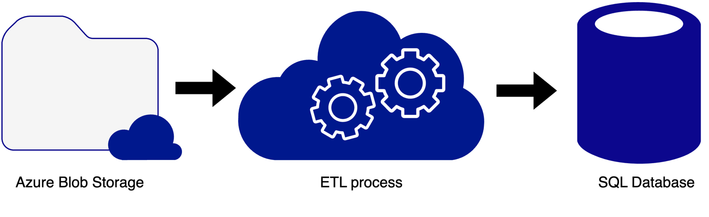

***Figure 3.****1 illustrates the overall architecture of the data processing pipeline, representing the key components and data flow. 1. Azure Blob Storage: External cloud storage; 2. ETL Process: Function that performs the process of the data; 3. SQL Database: External SQL Database*

Components:

* Serverless Functions: Written in Python 3.9, these functions handle data ingestion, processing, and storage tasks.
* Data Storage: Utilizes Azure Storage Buckets for storing processed data and an Azure-managed PostgreSQL database for state management.
* Infrastructure:
  + For Knative, a Kubernetes cluster is deployed using Minikube on an Azure Virtual Machine.
  + For Azure Functions, a serverless environment is set up using the Azure portal.

**Data Ingestion and ETL Process**

The data processing pipeline begins by retrieving the data from Azure Blob Storage. This step is essential for ensuring that the pipeline can efficiently manage data from cloud storage solutions. The ingestion process is designed to handle large datasets without significant delays.

Once the data is ingested, the pipeline starts the ETL processes. During extraction, raw data is pulled from the CSV file stored in Azure Blob Storage. This raw data often contains inconsistencies, missing values, and anomalies that need to be addressed.

In the transformation phase, the data is prepared for cleaning and normalization. This phase simulates real cases when it is necessary to ensure that the data is in a suitable format for subsequent analysis and storage. Data cleaning involves handling missing values, correcting inconsistencies, and ensuring the data adheres to a specified schema. Normalisation involves structuring the data to reduce redundancy and improve data integrity.

**Data Storage and Management**

After the data is cleaned and normalised, it is sent to an external database for storage. The Azure Database for PostgreSQL flexible server is utilised for this purpose. This database solution is chosen for its flexibility and capability to effectively simulate an external source storage, allowing encapsulation for future tests. Azure Database for PostgreSQL offers several benefits, including high availability, automated backups, and scalable resources.

This scenario provides a detailed exploration of a data processing pipeline in a cloud environment, simulating a real-world case of data migration and processing. The insights gained from this setup are crucial for understanding the challenges and solutions associated with modern data management practices. By utilising Azure Blob Storage and Azure Database for PostgreSQL flexible server, the scenario effectively demonstrates the potential of cloud-native solutions to handle large datasets, ensuring reliability, scalability, and efficiency.

This Scenario aligns with the project aim of exploring serverless computing and comparing leading architectures such as Knative and Azure Functions. This specific data processing pipeline scenario will be used to evaluate the performance and scalability of these platforms. The study aims to provide insights into the comparative advantages and limitations of these serverless solutions, guiding stakeholders in selecting the optimal architecture for their needs.

* + - 1. **Healthcare Orchestration Pipeline**

The enterprise backend system designed here simulates a healthcare environment where data interoperability is critical. The function presented uses asynchronous processing, which allows tasks to be performed concurrently and independently, ensuring high efficiency and responsiveness.

The function ingests data from an external source, in this case, an external database, representing a common scenario when healthcare companies are required to integrate their data. Upon obtaining the data, the system orchestrates a series of serverless functions to transform and validate it according to the FHIR(Fast Healthcare Interoperability Resources) standard.

The healthcare orchestration pipeline scenario aligns with the project’s aim of exploring serverless computing and comparing leading architectures such as Knative and Azure Functions. By developing and utilising a suite of benchmarks tailored to real-world application scenarios, The results gained provide valuable guidance to stakeholders in selecting the optimal serverless architecture for their needs.

**Architecture of the Healthcare Orchestration Pipeline**

Figure 3.2 illustrates the architecture of the healthcare orchestration pipeline, outlining the key components and the flow of the data:

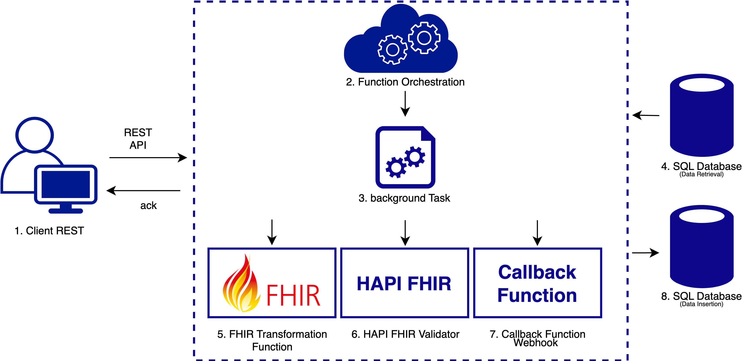

*Figure 3.2 Healthcare Orchestration Pipeline Architecture*

1. Client Rest:

The process begins with a client REST API triggering the system to start the data processing pipeline. The client can send data directly or specify parameters, such as a date range, to extract medication data. This flexibility allows the function to be used for periodic transmission of medication data from external sources or legacy systems that require normalisation to the FHIR standard. An acknowledgement (ack) message is sent back to confirm receipt and initiation of the process.

1. Function Orchestration:

After receiving the request with parameters, the function orchestration component is triggered. This step coordinates the execution of different functions and external services necessary for processing the data. Orchestration ensures that each function is executed in the correct sequence and that data flows smoothly between functions. It handles dependencies, manages state, and ensures that each component is executed efficiently.

1. Background Task:

The orchestration includes a background task that handles the primary processing of the data, ensuring that all necessary transformations and validations are executed. This task is executed asynchronously and is responsible for the primary processing of the data. By offloading these tasks to the background, the system can ensure real-time processing without blocking the main thread of execution.

1. SQL Database (Data Retrieval):

The function retrieves data from an external SQL database, executing a query for a specific range of dates to extract the last data inserted in the legacy systems or new data generated by the healthcare company. This simulates a common requirement for this type of process in healthcare companies.

1. FHIR Transformation:

The first step involves transforming the incoming data into the FHIR(Fast Healthcare Interoperability Resources) standard format. The FHIR Transformation function parses the data and converts it into the schema standard for FHIR resources. This transformation is crucial because FHIR provides a standardised format for healthcare data exchange, allowing interoperability between different healthcare systems.

1. HAPI FHIR Validator:

Once the data is transformed into the FHIR format, it is passed to the HAPI FHIR Validator. HAPI FHIR is an open-source implementation of the FHIR standard that provides tools for validating FHIR resources(Smile Digital Health, 2024). The validator checks the transformed data against FHIR specifications to ensure that it meets all required fields and doesn’t present errors, assuring the data quality.

1. SQL Database (Data Insertion):

After being transformed and validated, the data is inserted into an external SQL database following the FHIR schema. Storing the data in a standardised format ensures that it can be easily accessed and used by other healthcare systems and applications. This step is critical for maintaining a centralised and organised data repository.

1. Callback Function Webhook.

Finally, once the entire process is complete, an ACK (acknowledgement) message is sent back to the client, confirming that the data was processed successfully. This message provides the client with the status of the operation, ensuring transparency and enabling the client to take any necessary follow-up actions.

**Asynchronous Processing and Background Tasks**

Asynchronous processing is a key aspect of modern serverless architectures. It allows tasks to be performed concurrently and independently. The Asynchronous processing method ensures that long-running operations do not block the main thread of execution, thereby enhancing the system's responsiveness and efficiency. In the Healthcare Orchestration Pipeline, asynchronous processing is managed through background tasks, which handle intensive processing activities without impacting the system’s ability to handle new requests.

The described healthcare orchestration pipeline scenario provides a comprehensive exploration of how an enterprise backend system can handle healthcare data using serverless functions. By simulating a real-world healthcare scenario, the design proposed demonstrates how serverless architectures can address the critical needs of data interoperability in the healthcare sector, ensuring that data is processed accurately and efficiently

* 1. **Metrics**

The performance and scalability of the serverless platforms will be evaluated using the following metrics:

1. **Execution Time:** The total time taken to execute functions from invocation to completion.
2. **Response Time:** The time taken for the serverless platform to respond to a request, including queuing and execution delays.
3. **CPU Usage:** The percentage of CPU resources utilized during function execution provides insights into computational efficiency.
4. **Memory Usage:** The amount of memory consumed by the functions, indicating the resource footprint of each platform.
5. **Scalability Efficiency:** The platforms' ability to scale up and down in response to varying loads reflects their flexibility and responsiveness.
   1. **Benchmarks**

A set of benchmarks has been developed to evaluate the performance and scalability of serverless platforms effectively. These benchmarks are designed to rigorously test various platform performance metrics under real-world application scenarios, providing quantitative data for a thorough comparative analysis.

The benchmarks focus on critical performance metrics such as latency, resource utilisation and adaptive scaling efficiency. The goal is to create a standardised set of tests that can be applied consistently across different serverless platforms, facilitating an objective comparison.

* + 1. **Latency Measurement**

The latency measurement benchmark aims to rigorously assess the average response time of serverless functions under varying load conditions, thus evaluating the platform's efficiency in handling concurrent requests. By deploying the data processing pipeline and simulating different levels of concurrent requests (specifically at 100, 1,000, and 10,000 requests), response times are recorded using high-precision monitoring tools. This approach ensures that latency is accurately measured across a spectrum of load conditions, providing a comprehensive understanding of the platform's performance. The average response time, measured in milliseconds, represents the platform's capability to process requests swiftly under different load scenarios, directly reflecting its responsiveness and efficiency.

* + 1. **Latency Measurement**

The latency measurement benchmark aims to rigorously assess the average response time of serverless functions under varying load conditions, thus evaluating the platform's efficiency in handling concurrent requests. By deploying the data processing pipeline and simulating different levels of concurrent requests (specifically at 100, 1,000, and 10,000 requests), response times are recorded using high-precision monitoring tools. This approach ensures that latency is accurately measured across a spectrum of load conditions, providing a comprehensive understanding of the platform's performance. The average response time, measured in milliseconds, represents the platform's capability to process requests swiftly under different load scenarios, directly reflecting its responsiveness and efficiency.

* + 1. **Throughput Testing**

To evaluate the platform’s capacity for managing high-volume traffic efficiently, the throughput testing benchmark measures the number of requests handled per second. By generating a high volume of concurrent requests directed at the data processing pipeline, the number of successful requests processed per second is precisely measured. This benchmark highlights the platform's throughput capabilities under stress conditions, demonstrating its scalability and efficiency in high-traffic environments. The requests per second (RPS) metric indicates the platform's ability to handle large volumes of traffic, which is essential for applications requiring high concurrency and real-time processing.

* + 1. **Resource Utilization**

The resource utilization benchmark monitors and analyses the CPU and memory usage of the serverless platform during function execution, evaluating the efficiency of resource management. By deploying the data processing pipeline and collecting detailed statistics on CPU and memory usage under varying load conditions, accurate data on resource consumption is gathered. This analysis reflects the true operational behaviour of the platform. The CPU and memory usage, measured as a percentage, is critical as it reflects how efficiently the serverless platform utilises available resources, directly impacting operational costs and performance.

* + 1. **Adaptive Scaling Efficiency (ASE)**

To assess the efficiency and responsiveness of the platform's auto-scaling mechanisms in adapting to rapid changes in workload, the adaptive scaling efficiency benchmark simulates sudden and significant variations in workload. For instance, an increase from 100 to 10,000 requests per second, followed by a decrease back to 100 requests per second, is simulated. The time taken for the platform to scale up and down and the resource utilisation during these scaling events are measured. This approach provides insights into the platform's dynamic scaling capabilities and resource management under real-world conditions. The metrics include scaling latency (seconds), which measures the time taken for the platform to adjust to changes in workload, and resource utilisation efficiency (percentage), which evaluates the efficiency of resource usage during scaling.

* 1. **Hypotheses**

The empirical investigation is guided by the following hypotheses, with a focus on comparing leading serverless architectures, including Knative and Azure Functions:

* H1: Serverless platforms, Knative and Azure Functions, exhibit significant differences in execution time and response time under varying load conditions.
* H2: Function complexity has a measurable impact on CPU and memory usage across different serverless platforms, including Knative and Azure Functions.
* H3: The scalability efficiency of serverless platforms, particularly Knative and Azure Functions, varies significantly, affecting their suitability for different real-world application scenarios.
* H4: There are identifiable patterns and anomalies in the performance metrics that highlight the comparative advantages and limitations of each serverless platform, including Knative and Azure Functions.
  1. **Experimental Setup**

To ensure the collection of reliable and valid data, the experimental setup involved several critical steps, detailed as follows:

* + 1. **Experimental Design**

The experimental design incorporated multiple stages to achieve a rigorous evaluation of the serverless platforms.

* Benchmark Development: Benchmarks were developed to accurately simulate real-world application scenarios previously described. This involved defining tasks representative of typical serverless functions to ensure practical relevance.
* Environment Configuration: Serverless platforms were configured within a controlled environment to maintain consistency across experiments. This setup included configuring cloud infrastructure, setting up monitoring tools, and deploying identical function code on each platform.
* Controlled Environment: Standardized virtual machines or containerised environments were utilised to deploy the serverless platforms. This standardisation ensured consistent hardware specifications and network conditions across all tests, minimising variability.
* Benchmark Execution: Benchmarks were executed on each platform under varying load conditions, and performance data was meticulously collected. Automation tools and scripts facilitated the generation of concurrent requests and the measurement of platform responses.
* Automation Tools: Tools such as Apache JMeter and Postman were employed to simulate varying load conditions and collect detailed performance metrics. Custom scripts orchestrated the benchmark execution, ensuring systematic data gathering.
  + 1. **Data Collection Tools**

The tools used for collecting and processing data were crucial to the success of the experimental investigation.

* Prometheus and Grafana: Prometheus was used for real-time monitoring and collecting data on CPU and memory usage. Grafana provided dashboards for visualising these metrics, aiding in real-time analysis.
* Custom Scripts: Custom scripts automated the execution of benchmarks, the collection of performance data, and the processing of results, ensuring consistency and repeatability in experiments.
* Azure Monitor and Azure Log Analytics: Microsoft Azure provides native monitoring and logging tools. Azure Monitor collects metrics and logs, while Azure Log Analytics offers advanced data analysis and visualisation capabilities.
  + 1. **Data Analysis Methods**

Data analysis involved multiple steps to derive meaningful insights from the collected data.

* Statistical Analysis: Statistical techniques were employed to compare performance metrics across platforms. Means, standard deviations, and confidence intervals were calculated to assess the significance of observed differences.
* Visualisation: Performance data was visualised using graphs and charts, which helped identify patterns or anomalies in the data.
* Comparative Analysis: The collected metrics were used to evaluate each platform's strengths and weaknesses. This comparative analysis included assessing execution times, response times, resource usage, and scalability efficiency to draw conclusions about each serverless architecture's relative performance.
  + 1. **Experimental Protocols**

Protocols were established to ensure the reliability and validity of the experimental results.

* Randomisation: The order of benchmark execution was randomised to minimise the impact of external factors. This ensured that any variations in performance were due to the platforms themselves rather than external influences.
* Replication: Experiments were repeated multiple times to ensure consistency and reliability of the results. Each benchmark was executed several times under each load condition to account for variability and ensure robust data.
* Control Variables: Environmental factors such as network conditions and hardware specifications were controlled to isolate the impact of the independent variables on the dependent variables. This control ensured that observed differences in performance were attributable to the serverless platforms rather than extraneous factors.

# Chapter 4 Implementation

* 1. **Software Solution**

This chapter details the implementation process of the software artefacts used to conduct our empirical investigation of serverless architectures. The focus is on two primary platforms: Knative, an open-source solution released by Google in 2018 that has become the most widely installed serverless layer on Kubernetes (Knative Blog, 2024), and Azure Functions, a cloud-native solution provided by Microsoft Azure. Both platforms were evaluated using a suite of benchmarks designed to test their performance and scalability in real-world application scenarios.

* + 1. **Experimental Environment.**

This section describes the controlled environment used for the experiments, detailing the technologies, hardware and configurations to ensure consistency and reliability

* + 1. **Knative implementation**

Knative, as an open-source solution, can be deployed in different environments; Knative works on most local deployments of Kubernetes; for prototyping purposes, it requires at least 3CPUs and 3GB of RAM available for the cluster to be created Knative Documentation, 2024a). For production purposes, it is recommended that a single-node cluster has at least 6 CPUs. 6GB of memory and 30 GB of disk storage. Additionally, the cluster should use Kubernetes v.128 or newer, and the Kubectl CLI must be installed. It is also essential that the Kubernetes cluster has internet access to fetch images or follows guidelines for deploying images from a private registry (Knative Documentation, 2024b).

**Setup and Configuration:**

The Knative platform was deployed on a dedicated Azure VM configured with the following specifications:

|  |  |
| --- | --- |
| **Heading One** | **Heading Two** |
| 1. Location | East US (Zone 1) |
| 2. VM Name | Knative-f |
| 3. Operating System | Ubuntu 20.04 LTS (Linux) |
| 4. VM Size | Standard D4s v3 (4 vCPUs, 16 GiB memory) |
| 5. Public Ip Address | 48.216.250.130 |
| 6. Virtual Network/Subnet | sc23fjrl/default |

The VM server provides the necessary computational resources and network configurations to prepare an adequate environment where Knative could be deployed.

**Kubernetes Cluster:** A local Kubernetes cluster was set up using Minikube on the Azure VM. This setup allowed for the deployment and management of Knative components, allowing Kubernetes orchestration capabilities to handle serverless functions.

* Minikube supports the latest Kubernetes release and up to six previous minor versions, ensuring compatibility with recent features and updates. Minikube supports multiple container runtimes and offers advanced features like LoadBalancer, filesystem mounts, FeatureGates, and network policies, as well as common continuous integration (CI) environments (Minikube, 2024).

Both Knative Serving and Eventing were installed to facilitate the deployment of serverless functions. Knative Serving managed the deployment and scaling of containerized applications, while Knative Eventing enabled event-driven communication between services.

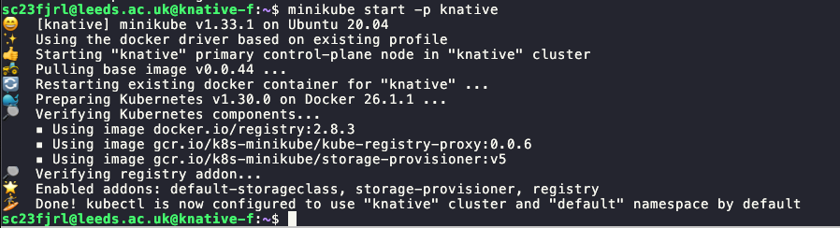

Figure 12 Starting Knative on virtual Machine

**Knative Configuration**

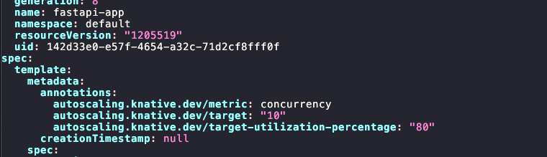

Figure 2 Knative configuration for autoscaling

To configure the fastapi-app Knative service to autoscale based on the number of concurrent requests, ensuring that it maintains at least one running pod at all times and scales up as needed based on traffic.

Steps and Explanation:

Edit Knative Service Configuration:

Use the kubectl edit ksvc fastapi-app command to open the current configuration of the fastapi-app service for editing.

Add Autoscaling Annotations:

In the configuration file, under the template.metadata.annotations section, add the following annotations to enable autoscaling based on concurrency:

autoscaling.knative.dev/minScale: Sets the minimum number of pods to 1, ensuring that there is always at least one pod running.

autoscaling.knative.dev/target: Sets the target number of concurrent requests per pod to 10. This is a soft concurrency limit, meaning each pod will try to handle up to 10 concurrent requests before the autoscaler decides to add more pods.

autoscaling.knative.dev/metric: Specifies that the autoscaler should use concurrency (number of requests) as the metric for scaling.

* + 1. **Azure Functions Implementation**

Azure Functions is a serverless compute service that enables run functions event-triggered code without having to explicitly provision or manage infrastructure. In this investigation, Azure Functions were configured to handle serverless functions efficiently and create integration with external sources, simulating real-world cases.

**Setup and Configuration:**

* Name: The function app was named Crud-Functionscfr.
* Publishing Model: The code was deployed using the publishing model.
* Runtime Stack: Python 3.11 was used as the runtime stack, taking advantage of its modern features and robust library support.
* Hosting Plan: The function app was hosted using an App Service plan named ASP-sc23fjrl-b894, operating under a Dynamic Y1 SKU that allows for dynamic scaling based on the application's needs.

**Deployment Process:**

The primary interface used for creating and managing Azure Functions was the Azure Portal. Through the portal, new Function Apps were created to host the individual functions. Each Function App acted as a container for one or more functions, sharing the same configurations and resources.

* Resource Group: Functions were organized within a resource group named sc23frl, allowing for better management and monitoring of related resources.
* App Service Plan: An App Service Plan was configured to define the underlying resources for the Function App. This included specifying the pricing tier, which impacts the scalability and performance of the functions.

**Networking Configuration:**

* Virtual IP Address: 40.71.177.34
* Outbound IP Addresses: The function app could communicate with external services through a set of outbound IP addresses:
* Primary: 40.71.1.129, 52.170.233.65, 40.71.3.54, 52.191.115.185, 40.71.177.34
* Additional: 104.211.20.160, 104.211.22.67, 20.253.0.46, 20.253.0.172, 20.253.0.252, 20.253.1.6, 20.253.1.7, 20.253.3.130, 20.83.130.84, 20.83.130.143, 20.83.131.80, 20.83.131.189, 20.83.131.228, 20.83.131.238, 40.71.177.34
* Virtual Network Integration: This configuration is not supported.

**Monitoring and Logging:**

* Application Insights: An Application Insights instance named Crud-Functionscfr was configured in the East US region to provide detailed monitoring and logging. This enabled real-time insights into the performance and health of the functions.

**Functions Development:**

* Language and Runtime: Functions were developed in Python 3.11, leveraging its rich ecosystem of libraries for data processing and healthcare orchestration tasks.
* Environment Configuration: Environment variables were set up within the Function App settings to manage sensitive information like connection strings and API keys securely.
* Function Configuration: Each function had its own configuration file (function.json) specifying the bindings and triggers. This file defined how the function should be triggered and what input/output bindings to use.
* Dependencies Management: Python dependencies were managed using a requirements.txt file. This file listed all necessary libraries, ensuring consistent environments across development, testing, and production.

**Integration with Azure Services:**

* Blob Storage: Functions were integrated with Azure Blob Storage for efficient data storage and retrieval. This setup facilitated the ingestion of large datasets, which were then processed by the functions.
* Azure Database for PostgreSQL: Used for persistent data storage, ensuring that processed data could be stored and retrieved efficiently. Functions interacted with the database using standard libraries like psycopg2 for Python.

**Deployment and Continuous Integration/Continuous Deployment (CI/CD):**

* Azure DevOps: CI/CD pipelines were set up using Azure DevOps. This allowed for automated deployment of functions from a GitHub repository. The pipeline included stages for building the code, running tests, and deploying to the Function App.
* Version Control: All function code was maintained in a GitHub repository, enabling version control and collaborative development.
* Automated Testing: Unit and integration tests were included in the CI/CD pipeline to ensure the reliability and correctness of the functions before deployment.

**Features:**

* Automatic Scaling: Azure Functions automatically scale based on the number of incoming events, ensuring that they can handle varying loads without manual intervention.
* Event-Driven Execution: Functions were designed to execute in response to specific events, providing a responsive and efficient way to handle tasks.
* Cost Efficiency: Azure Functions' consumption-based pricing model means that costs are incurred only when functions are executed, providing a cost-effective solution for managing workloads.
  1. **Technology Stack**

This section describes a detailed overview of the technology stack, including libraries and tools used for the development, deployment, and execution of the serverless functions presented in this investigation, including both Knative and Azure functions.

The stack includes a variety of programming languages, frameworks, libraries, and services that work together to provide a robust and scalable solution.

**Programming Languages and Frameworks**

Python 3.9: This is the primary programming language used for developing the serverless functions. Python was chosen for its simplicity, readability, and extensive library support.

Flask is a micro web framework written in Python. It is lightweight and easy to set up, making it ideal for building web applications quickly.

Fast API is a modern, fast (high-performance) web framework for building APIs with Python 3.6+ based on standard Python type hints.

#TODO ADD more context

**Programming Languages and Frameworks**

The following Python libraries were used across different modules in the project:

* Pydantic: Data validation and settings management using Python type annotations.
* Numpy: A fundamental package for scientific computing with Python.
* Parliament Functions: Library for creating serverless functions with various cloud providers.
* Werkzeug: A comprehensive WSGI web application library.
* Azure Storage Blob: Azure library for handling storage blobs.
* Psycopg2-binary: PostgreSQL database adapter for Python.
* FHIR Resources: Library for handling FHIR (Fast Healthcare Interoperability Resources) data.
* Flask: A micro web framework for building web applications.
* FastAPI: A modern, fast (high-performance) web framework for building APIs.
* Flask-RESTful: An extension for Flask that adds support for quickly building REST APIs.
* Flask-SQLAlchemy: An extension for Flask that adds support for SQLAlchemy, a SQL toolkit and Object-Relational Mapping (ORM) library.
* SQLAlchemy: SQL toolkit and Object-Relational Mapping (ORM) library for Python.
* Pandas: A fast, powerful, flexible, and easy-to-use open-source data analysis and data manipulation library.
* Logging: The standard logging library in Python used for logging runtime information.
* OS: Used for interacting with the operating system.
* JSON: For parsing and generating JSON data.

**Docker and Containerization**

Docker is used to containerise the application, ensuring that it can run consistently across different environments. The Dockerfile specifies the environment and dependencies required for the application.

**Tools and Services**

* Azure DevOps: Used for CI/CD pipelines to automate testing and deployment.
* Prometheus: For collecting and aggregating metrics from the application.
* Grafana: For visualising and monitoring the metrics collected by Prometheus.
* Azure Monitor and Log Analytics: For monitoring Azure Functions and providing detailed logs and metrics.

#TODO ADD Modules and Files

This technology stack ensures that the application is robust, scalable, and maintainable, leveraging modern tools and frameworks to handle serverless workloads efficiently.

* 1. **Data Sets**

Data sets were chosen to replicate real-world scenarios in data processing and healthcare orchestration, providing a robust basis for performance evaluation.

* + 1. **Data Processing Pipeline**

Dataset: "250k Medicines Usage Side Effects and Substitutes" from Kaggle.

Size: Approximately 248,000 records.

Content: Included drug names, active ingredients, therapeutic uses, dosages, side effects, and substitutes. This dataset simulated a common use case in healthcare data management, requiring significant processing power and efficient data handling.

* + 1. **Healthcare Orchestration Pipeline**

Dataset: Simulated healthcare data in SQL format.

Content: Contained patient records, medication details, appointment schedules, and treatment plans.

Transformation: Data was converted to the FHIR (Fast Healthcare Interoperability Resources) standard and validated using HAPI FHIR Validator, ensuring interoperability across healthcare systems.

* 1. **Tooling**

Apache JMeter: Utilized to generate load and simulate concurrent requests to the serverless functions, ensuring that the platforms were tested under realistic and high-stress conditions.

Custom Scripts: These scripts were developed to automate the deployment, execution, and monitoring of benchmarks on both Knative and Azure Functions, minimizing manual intervention and reducing potential errors.

* 1. **Execution of Benchmarks**

This section details the execution of the experiments conducted to evaluate the scalability and performance of the Knative service and Azure Functions under different load conditions. The experiments were configured using Apache JMeter, with specific thread group settings and throughput shaping timers to simulate varying loads. The goal was to understand how the service handles increasing request rates and user concurrency.

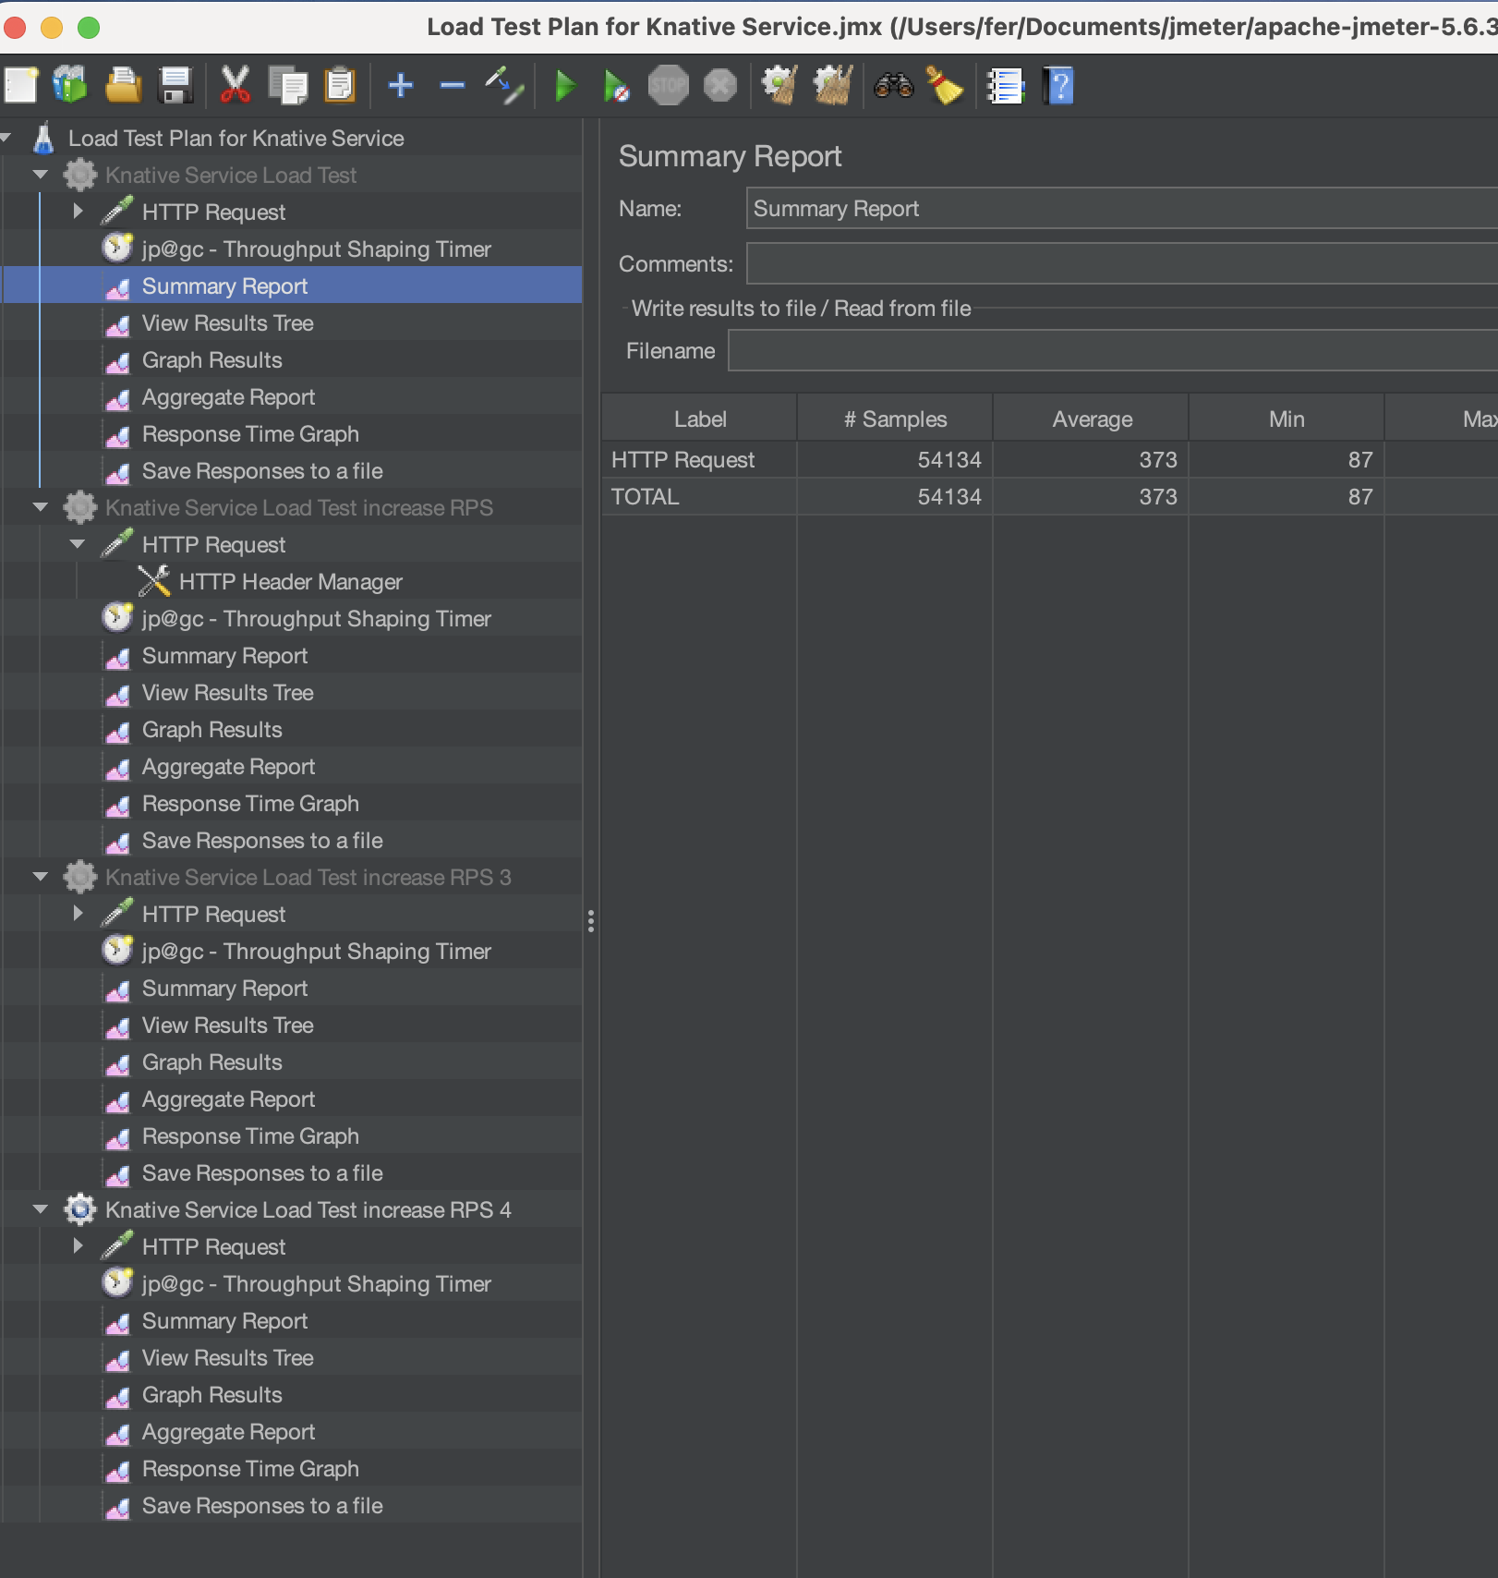

Figure 3 Setup JMeter with Test Plan Implemented

**Experiment 1: Moderate Load Test**

Title: Moderate Load Test for Knative Service

**Objective:**

To assess the performance of the Knative service under a moderate load scenario, simulating an environment with increasing but manageable request rates. This experiment aims to determine how the service scales when subjected to a moderate number of concurrent users and a moderate rate of requests per second (RPS).

**Configuration:**

|  |  |  |
| --- | --- | --- |
| **Component** | **Parameter** | **Value** |
| Tread Group | Name | Knative Service Load Test |
|  | Number of Threads | 50 |
|  | Ramp-Up Period(seconds) | 30 |
|  | Loop Count | 3480 |
| Throughput Shaping Time | First Row – Start RPS | 100 |
|  | First Row – End RPS | 400 |
|  | First Row – Duration(seconds) | 120 |
|  | Second Row – Start RPS | 400 |
|  | Second Row – End RPS | 400 |
|  | Second Row – Duration(seconds) | 300 |

This experiment simulates a moderate load scenario where the system experiences a steady increase in traffic followed by an increased load. The Throughput Shaping Timer gradually increases the request rate from 100 to 400 RPS and then maintains it. it can be observed how the service handles a controlled, increasing load and stabilises under sustained pressure. This helps identify the service's performance characteristics under moderate load conditions.

Figure 4

In this experiment, the stateless nature of the Knative service is important because it allows the service to handle each request independently without maintaining any session state between requests. This means that the service can scale horizontally by adding more instances to handle the increased load, making it easier to manage and predict performance under varying loads.

**Experiment 2: Moderate Load Test**

Title: Moderate Load Test for Knative Service

**Objective:**

This experiment evaluates the Knative service's performance under Moderate load conditions, representing a significant increase in user concurrency and request rates. It helps identify potential bottlenecks and the service's capacity to handle higher traffic volumes.

**Configuration:**

|  |  |  |
| --- | --- | --- |
| **Component** | **Parameter** | **Value** |
| Tread Group | Name | Knative Service Load Test |
|  | Number of Threads | 100 |
|  | Ramp-Up Period(seconds) | 30 |
|  | Loop Count | 3480 |
| Throughput Shaping Time | First Row – Start RPS | 200 |
|  | First Row – End RPS | 800 |
|  | First Row – Duration(seconds) | 120 |
|  | Second Row – Start RPS | 800 |
|  | Second Row – End RPS | 800 |
|  | Second Row – Duration(seconds) | 300 |

In this high-load test, the Throughput Shaping Timer allows us to incrementally increase the load from 200 to 800 RPS and then maintain a steady high load. This configuration helps understand how the service copes with a substantial increase in requests and whether it can maintain performance and stability under significant traffic loads. It is essential for identifying potential performance bottlenecks and ensuring the service's robustness.

Figure 5

As with the previous experiment, the stateless architecture of the Knative service is key. Handling each request independently allows for efficient horizontal scaling, ensuring performance is maintained even as the load increases significantly. This experiment tests the limits of this scalability and the ability to handle higher traffic without degradation.

**Experiment 3: High Load Test**

**Objective:**

To push the Knative service to handle very high load conditions, representing a substantial increase in user concurrency and request rates. This experiment helps identify potential bottlenecks and the service's capacity to handle high traffic volumes

**Configuration:**

|  |  |  |
| --- | --- | --- |
| **Component** | **Parameter** | **Value** |
| Tread Group | Name | Knative Service Load Test |
|  | Number of Threads | 200 |
|  | Ramp-Up Period(seconds) | 60 |
|  | Loop Count | 3480 |
| Throughput Shaping Time | First Row – Start RPS | 400 |
|  | First Row – End RPS | 1600 |
|  | First Row – Duration(seconds) | 120 |
|  | Second Row – Start RPS | 1600 |
|  | Second Row – End RPS | 1600 |
|  | Second Row – Duration(seconds) | 300 |

In this test, the Throughput Shaping Timer is configured to increase the request rate significantly, from 400 to 1600 RPS, and then maintain that load. This is crucial for testing

the service's upper limits and understanding how it manages very high levels of concurrency and request rates. The results will provide insights into potential performance issues and the scalability of the service under substantial load conditions. The proposal experiment demonstrates how well the service can horizontally scale and maintain performance with a very high load, which is critical for applications expecting significant traffic.

Figure 6

**Experiment 4: Extreme Load Test**

**Objective:**

The experiment aims to push the Knative service to its limits by subjecting it to extreme load conditions. It also aims to discover the service's maximum capacity and stress points when faced with very high levels of concurrency and request rates.

**Configuration:**

|  |  |  |
| --- | --- | --- |
| **Component** | **Parameter** | **Value** |
| Tread Group | Name | Knative Service Load Test |
|  | Number of Threads | 400 |
|  | Ramp-Up Period(seconds) | 90 |
|  | Loop Count | 3480 |
| Throughput Shaping Time | First Row – Start RPS | 800 |
|  | First Row – End RPS | 3200 |
|  | First Row – Duration(seconds) | 120 |
|  | Second Row – Start RPS | 3200 |
|  | Second Row – End RPS | 3200 |
|  | Second Row – Duration(seconds) | 300 |

In the extreme load test, the Throughput Shaping Timer is essential for incrementally increasing the request rate from 800 to 3200 RPS and then maintaining that extreme load. This setup is critical for understanding the service's maximum capacity and identifying stress points. The timer ensures that the load is applied and controlled, allowing for accurate measurement of the service's performance under extreme conditions.

Figure 7

The ability to handle requests independently without maintaining state makes it easier for the service to scale horizontally and manage extremely high loads. This experiment tests the service's scalability to its limits, providing insights into its performance and potential areas for improvement under extreme traffic conditions.

* 1. **Results**

The results of the experiments are summarised in the following tables. Each experiment's summary includes key performance metrics such as the number of requests, response times, and any observed bottlenecks. Below are the summaries for each experiment based on the actual data.

**Experiment 1:**

|  |  |  |  |  |  |  |  |  |  |  |
| --- | --- | --- | --- | --- | --- | --- | --- | --- | --- | --- |
| **Label** | **# Samples** | **Average** | **Min** | **Max** | **Std. Dev.** | **Error %** | **Throughput** | **Received KB/sec** | **Sent KB/sec** | **Avg. Bytes** |
| **HTTP Request** | 54134 | 373 | 87 | 2568 | 137.24 | 0.000% | 128.61701 | 22.09 | 20.60 | 175.9 |
| **TOTAL** | 54134 | 373 | 87 | 2568 | 137.24 | 0.000% | 128.61701 | 22.09 | 20.60 | 175.9 |

Figure 8 KNATIVE 1

|  |  |  |  |  |  |  |  |  |  |  |
| --- | --- | --- | --- | --- | --- | --- | --- | --- | --- | --- |
| **Label** | **# Samples** | **Average** | **Min** | **Max** | **Std. Dev.** | **Error %** | **Throughput** | **Received KB/sec** | **Sent KB/sec** | **Avg. Bytes** |
| **HTTP Request** | 75667 | 267 | 131 | 4004 | 165.13 | 0.000% | 179.99795 | 36.91 | 27.77 | 210.0 |
| **TOTAL** | 75667 | 267 | 131 | 4004 | 165.13 | 0.000% | 179.99795 | 36.91 | 27.77 | 210.0 |

**Experiment 2:**

|  |  |  |  |  |  |  |  |  |  |  |
| --- | --- | --- | --- | --- | --- | --- | --- | --- | --- | --- |
| **Label** | **# Samples** | **Average** | **Min** | **Max** | **Std. Dev.** | **Error %** | **Throughput** | **Received KB/sec** | **Sent KB/sec** | **Avg. Bytes** |
| **HTTP Request** | 84533 | 478 | 86 | 2613 | 199.13 | 0.000% | 200.90980 | 34.52 | 32.18 | 175.9 |
| **TOTAL** | 84533 | 478 | 86 | 2613 | 199.13 | 0.000% | 200.90980 | 34.52 | 32.18 | 175.9 |

|  |  |  |  |  |  |  |  |  |  |  |
| --- | --- | --- | --- | --- | --- | --- | --- | --- | --- | --- |
| **Label** | **# Samples** | **Average** | **Min** | **Max** | **Std. Dev.** | **Error %** | **Throughput** | **Received KB/sec** | **Sent KB/sec** | **Avg. Bytes** |
| **HTTP Request** | 109519 | 369 | 131 | 4250 | 255.67 | 0.000% | 259.97650 | 53.31 | 40.11 | 210.0 |
| **TOTAL** | 109519 | 369 | 131 | 4250 | 255.67 | 0.000% | 259.97650 | 53.31 | 40.11 | 210.0 |

**Experiment 3:**

|  |  |  |  |  |  |  |  |  |  |  |
| --- | --- | --- | --- | --- | --- | --- | --- | --- | --- | --- |
| **Label** | **# Samples** | **Average** | **Min** | **Max** | **Std. Dev.** | **Error %** | **Throughput** | **Received KB/sec** | **Sent KB/sec** | **Avg. Bytes** |
| **HTTP Request** | 83984 | 930 | 88 | 2610 | 288.64 | 0.000% | 199.07271 | 34.27 | 31.88 | 176.3 |
| **TOTAL** | 83984 | 930 | 88 | 2610 | 288.64 | 0.000% | 199.07271 | 34.27 | 31.88 | 176.3 |

|  |  |  |  |  |  |  |  |  |  |  |
| --- | --- | --- | --- | --- | --- | --- | --- | --- | --- | --- |
| **Label** | **# Samples** | **Average** | **Min** | **Max** | **Std. Dev.** | **Error %** | **Throughput** | **Received KB/sec** | **Sent KB/sec** | **Avg. Bytes** |
| **HTTP Request** | 139755 | 558 | 133 | 4362 | 357.00 | 0.000% | 331.93360 | 68.07 | 51.22 | 210.0 |
| **TOTAL** | 139755 | 558 | 133 | 4362 | 357.00 | 0.000% | 331.93360 | 68.07 | 51.22 | 210.0 |

**Experiment 4:**

|  |  |  |  |  |  |  |  |  |  |  |
| --- | --- | --- | --- | --- | --- | --- | --- | --- | --- | --- |
| **Label** | **# Samples** | **Average** | **Min** | **Max** | **Std. Dev.** | **Error %** | **Throughput** | **Received KB/sec** | **Sent KB/sec** | **Avg. Bytes** |
| **HTTP Request** | 61519 | 2469 | 87 | 17592 | 1401.93 | 0.000% | 142.38202 | 24.60 | 22.80 | 177.0 |
| **TOTAL** | 61519 | 2469 | 87 | 17592 | 1401.93 | 0.000% | 142.38202 | 24.60 | 22.80 | 177.0 |

|  |  |  |  |  |  |  |  |  |  |  |
| --- | --- | --- | --- | --- | --- | --- | --- | --- | --- | --- |
| **Label** | **# Samples** | **Average** | **Min** | **Max** | **Std. Dev.** | **Error %** | **Throughput** | **Received KB/sec** | **Sent KB/sec** | **Avg. Bytes** |
| **HTTP Request** | 204062 | 735 | 131 | 5291 | 418.49 | 0.000% | 484.42593 | 99.34 | 74.75 | 210.0 |
| **TOTAL** | 204062 | 735 | 131 | 5291 | 418.49 | 0.000% | 484.42593 | 99.34 | 74.75 | 210.0 |

# Chapter 5 The Evaluation stage

* 1. **Technical Evaluation**

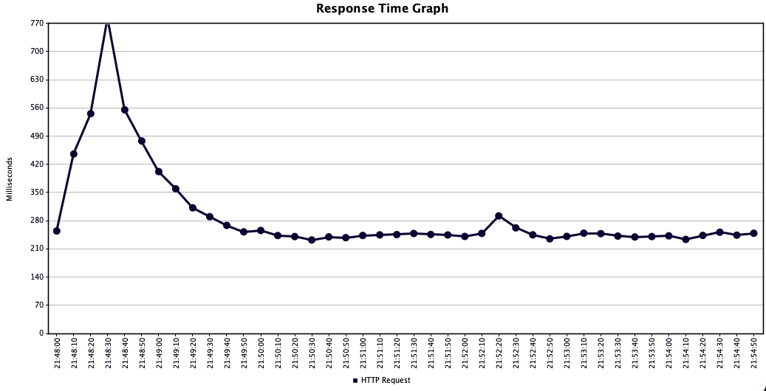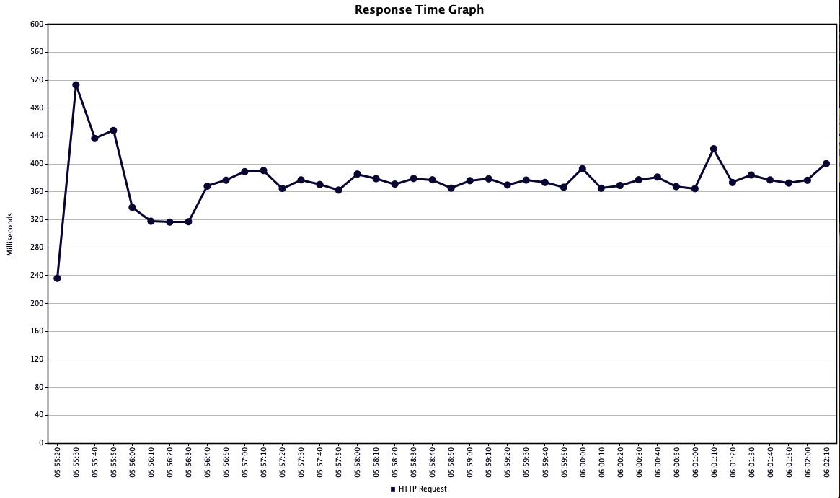

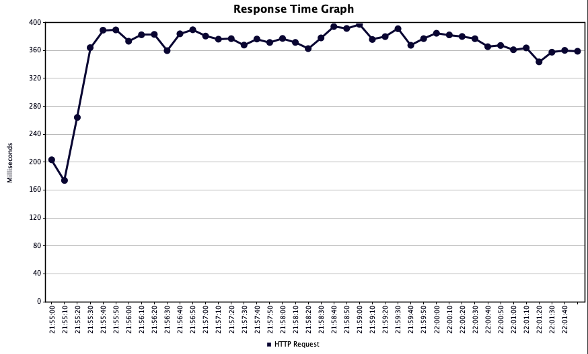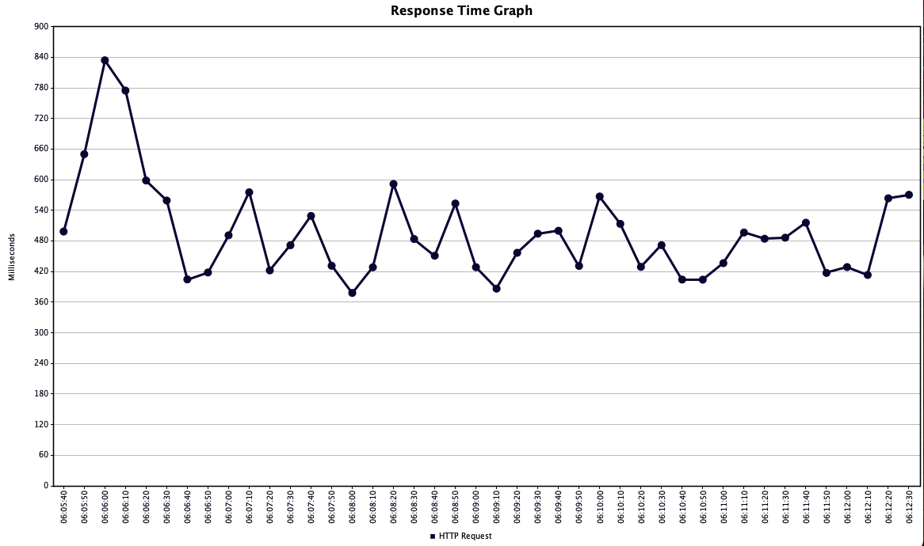

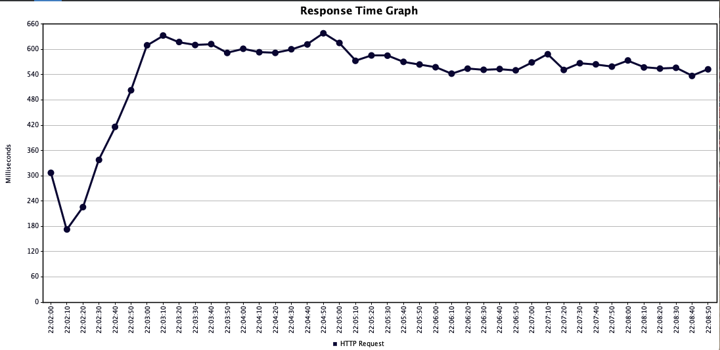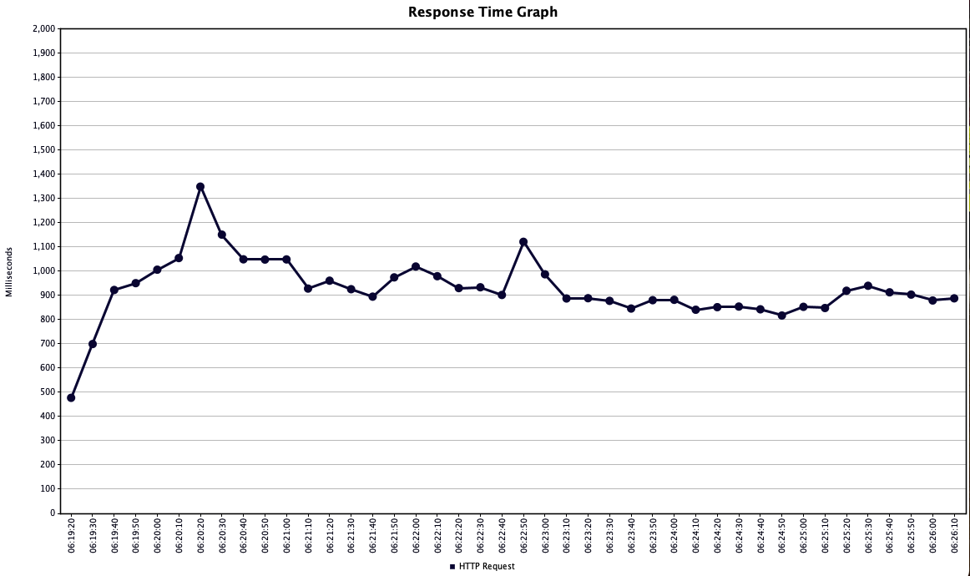

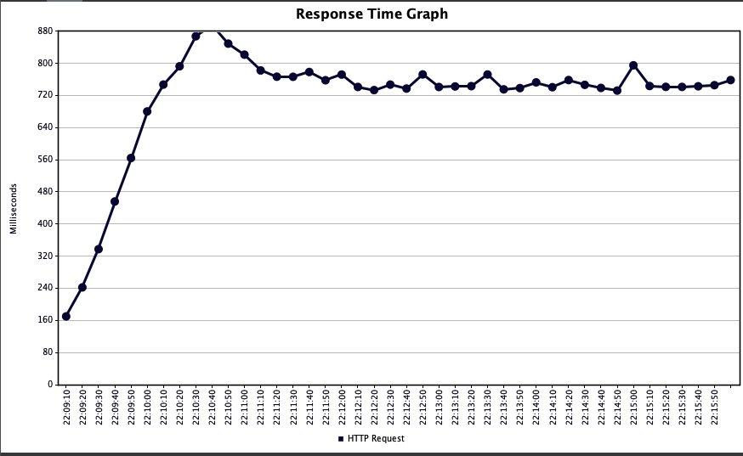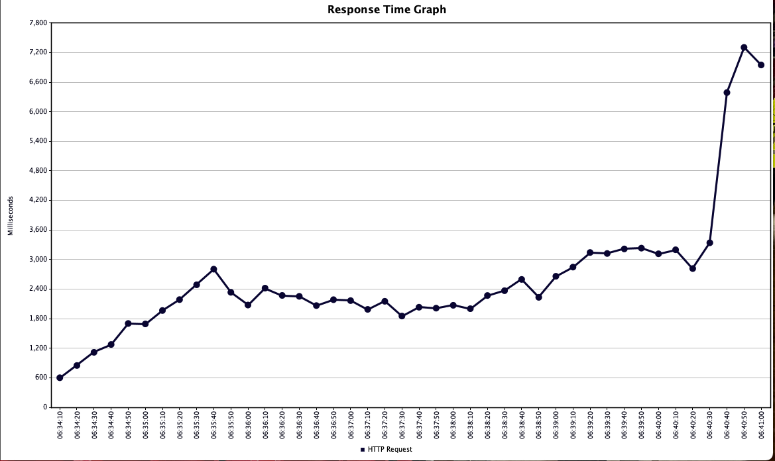

**KNATIVE Pods Autoscaling**

The Benchmark (experiment) were conducted on stateless services, which are designed to handle large volumes of traffic without retaining session information. This architecture enables horizontal scaling, as observed in the experiments. The ability to scale pods in response to load demonstrates the effectiveness of the stateless service design in managing high-traffic loads.

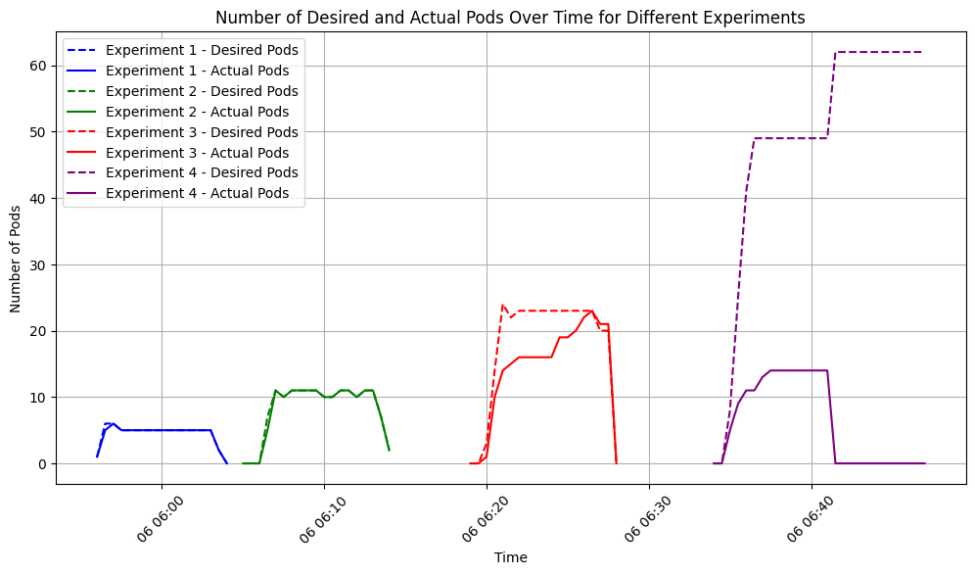

The results demonstrate that the Knative service can dynamically scale its resources (pods) based on the load. In lower load scenarios (Experiments 1 and 2), the actual number of pods closely follows the desired number with minimal delay. However, as the load increases (Experiments 3 and 4), the system shows some latency in scaling up, particularly under the highest load conditions in Experiment 4.

**System Responsiveness:**

The initial lag in actual pod count catching up to the desired count in higher load scenarios suggests that the system may require optimisation to improve responsiveness. This could involve tuning the autoscaling parameters or improving the underlying infrastructure's ability to provision new resources more quickly.

**Resource Allocation**

The experiments indicate that the system effectively manages resource allocation by scaling up the number of pods in response to increased traffic. However, the pronounced delay in Experiment 4 highlights the limitations of the current configuration when subjected to extreme load conditions.

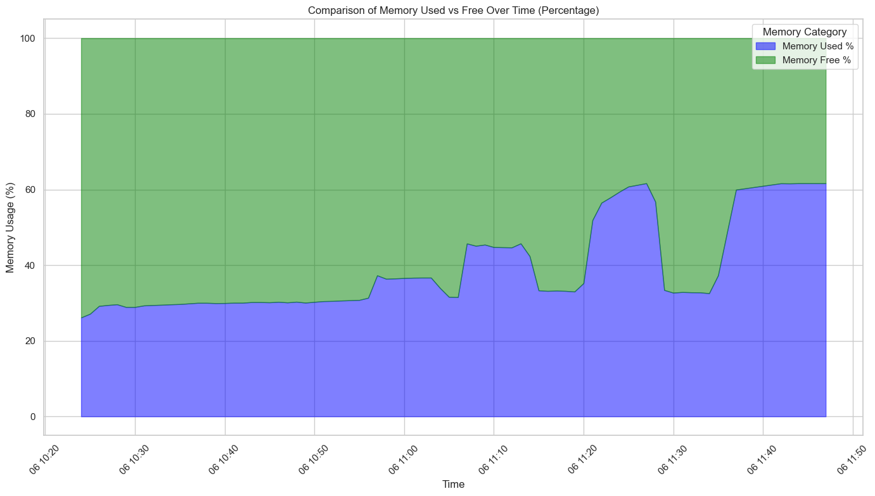

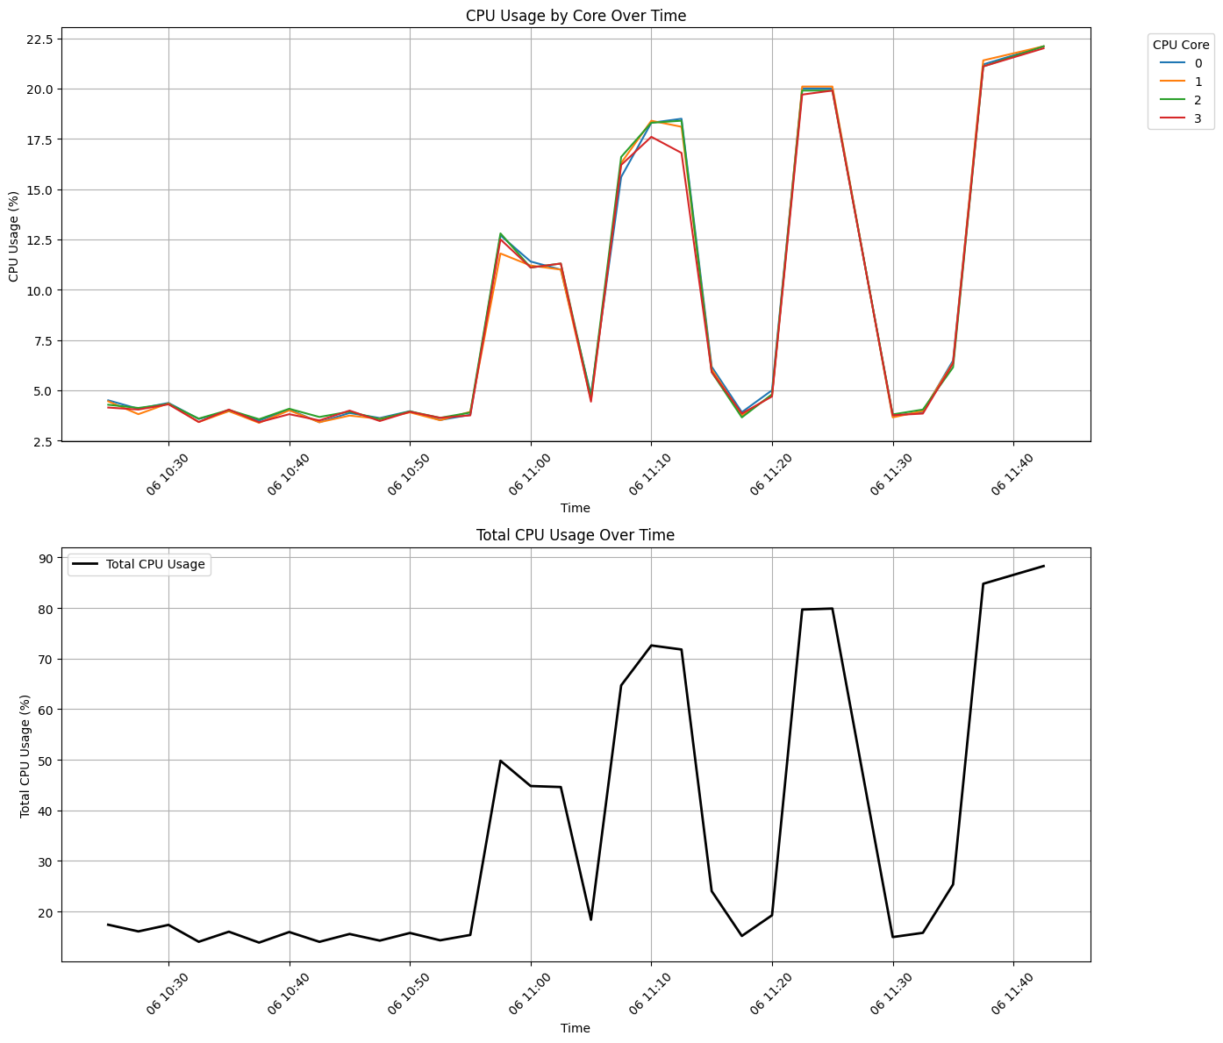

**Implications for Stateless Services**

The experiments were conducted on stateless services, which are designed to handle large volumes of traffic without retaining session information. This architecture enables horizontal scaling, as observed in the experiments. The ability to scale pods in response to load demonstrates the effectiveness of the stateless service design in managing high-traffic loads.

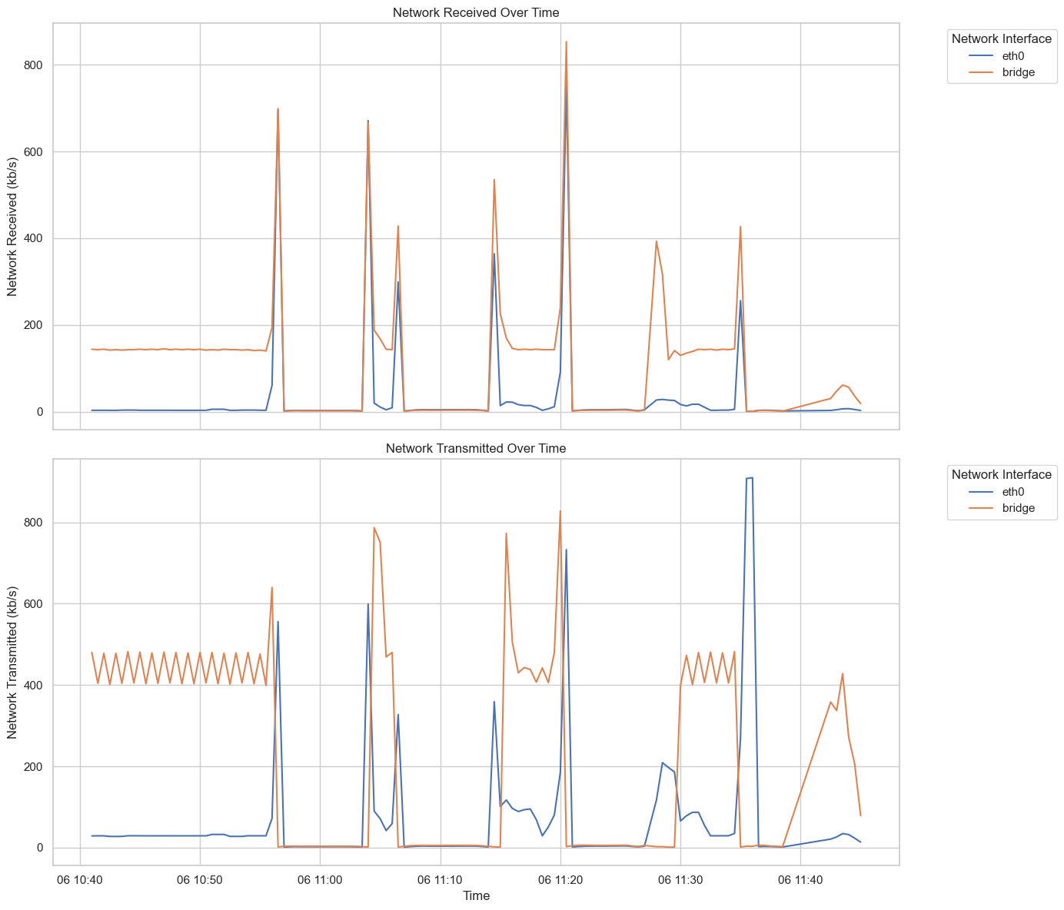

**Bottlenecks**

The substantial increase in desired pods in Experiment 4 caused resource contention and bottlenecks, leading to delays in provisioning new pods.

The infrastructure might not have been able to handle the rapid scaling demands in Experiment 4, resulting in slower response times.

**Impact on VM Environment**

After completing Experiment 4, the VM environment became unstable and had to be rebooted. This instability was likely due to the high load and resource consumption during the experiment. The substantial increase in traffic and the corresponding need for resources could

# Chapter 2 Tables and Figures

## 2.1 Tables using the ‘table caption’ and ‘table description’ Styles

Text before table. Text before table. Text before table. Text before table. Text before table. Text before table. Text before table. Text before table. Text before table. Text before table.

**Table 2.1** Caption of Table — automatically appears in the List of Tables when that is updated The ‘table caption’ style has been applied to this paragraph by pressing Ctrl Shift T.

This is the table description in the ‘table description’ style. It is optional text to give more information about the table and does not appear in the List of Tables.

|  |  |  |
| --- | --- | --- |
| **Heading One** | **Heading Two** | **Heading Three** |
| 1.1 | 1.2 | 1.3 |
| 1.21 | 1.22 | 12.3 |
| 12.31 | 12.32 | 12.33 |

## 2.2 Figures using the ‘figure caption’ and ‘figure description’ Styles

Figures can be added using the Illustrations section of the Insert tab.



**Figure 2.1** Caption of Figure — automatically appears in the List of Figures when that is updated. The ‘figure caption’ style has been applied to this paragraph by pressing Ctrl Shift F.

This is the figure description in the ‘figure description’ style. It is optional text to give more information about the figure and does not appear in the List of Figures.

# List of References

*<It is expected that the list would reflect the breadth and depth of scholarly research undertaken by the student during the course of the project.>*

Singh, S. (2021) '250k Medicines Usage, Side Effects and Substitutes', Kaggle. Available at: <https://www.kaggle.com/datasets/shudhanshusingh/250k-medicines-usage-side-effects-and-substitutes> (Accessed: 1 August 2024).

HL7 (2024) 'FHIR Overview', HL7. Available at: <https://www.hl7.org/fhir/overview.html> (Accessed: 3 August 2024).

Singh, S. (2021) '250k Medicines Usage, Side Effects and Substitutes', Kaggle. Available at: <https://www.kaggle.com/datasets/shudhanshusingh/250k-medicines-usage-side-effects-and-substitutes> (Accessed: 3 August 2024).

Smile Digital Health (2024) 'HAPI FHIR', HAPI FHIR. Available at: <https://hapi.fhir.org/baseR4/swagger-ui/> (Accessed: 3 August 2024).

Knative Blog (2024) Knative 1.0 Release. Available at: <https://knative.dev/blog/releases/knative-1.0/#:~:text=The%20Knative%20project%20was%20released,installed%20serverless%20layer%20on%20Kubernetes> (Accessed: 5 August 2024).

Knative Documentation (2024a) Getting Started with Knative. Available at: <https://knative.dev/docs/getting-started/quickstart-install/#before-you-begin> (Accessed: 5 August 2024).

Knative Documentation (2024b) Prerequisites for Installing Knative. Available at: <https://knative.dev/docs/install/yaml-install/serving/install-serving-with-yaml/#prerequisites> (Accessed: 5 August 2024).

# Appendix A External Materials

<Level 1 Heading with ‘heading 1’ Style Applied by Pressing Ctrl Shift 1> Text under appendix heading. Text under appendix heading. Text under appendix heading. Text under appendix heading. Text under appendix heading. Text under appendix heading.

## A.1 Level 2 Heading with ‘heading 2’ Style Applied by Pressing Ctrl Shift 2

Text under level 2 heading. Text under level 2 heading. Text under level 2 heading. Text under level 2 heading.

### A.1.1 Level 3 Heading with ‘heading 3’ Style Applied by Pressing Ctrl Shift 3

Text under level 3 heading. Text under level 3 heading. Text under level 3 heading. Text under level 3 heading.

#### A.1.1.1 Level 4 Heading with ‘heading 4’ Style Applied by Pressing Ctrl Shift 4

Text under level 4 heading. Text under level 4 heading. Text under level 4 heading. Text under level 4 heading.

# Appendix B Ethical Issues Addressed

Text under appendix heading. Text under appendix heading. Text under appendix heading. Text under appendix heading. Text under appendix heading. Text under appendix heading.

## B.1 Level 2 Heading

Text under level 2 heading. Text under level 2 heading. Text under level 2 heading. Text under level 2 heading.